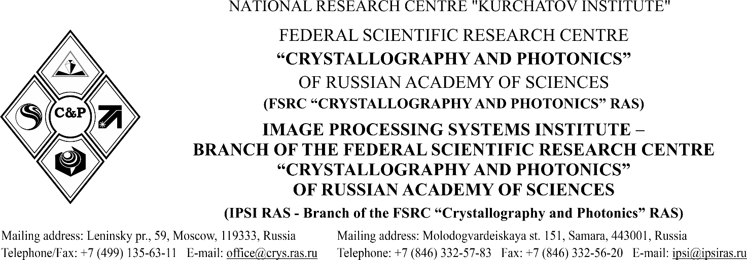
________________________________________________________________________________________________________________________________________________________________

______________№ 11205-
for №__________from_____________

