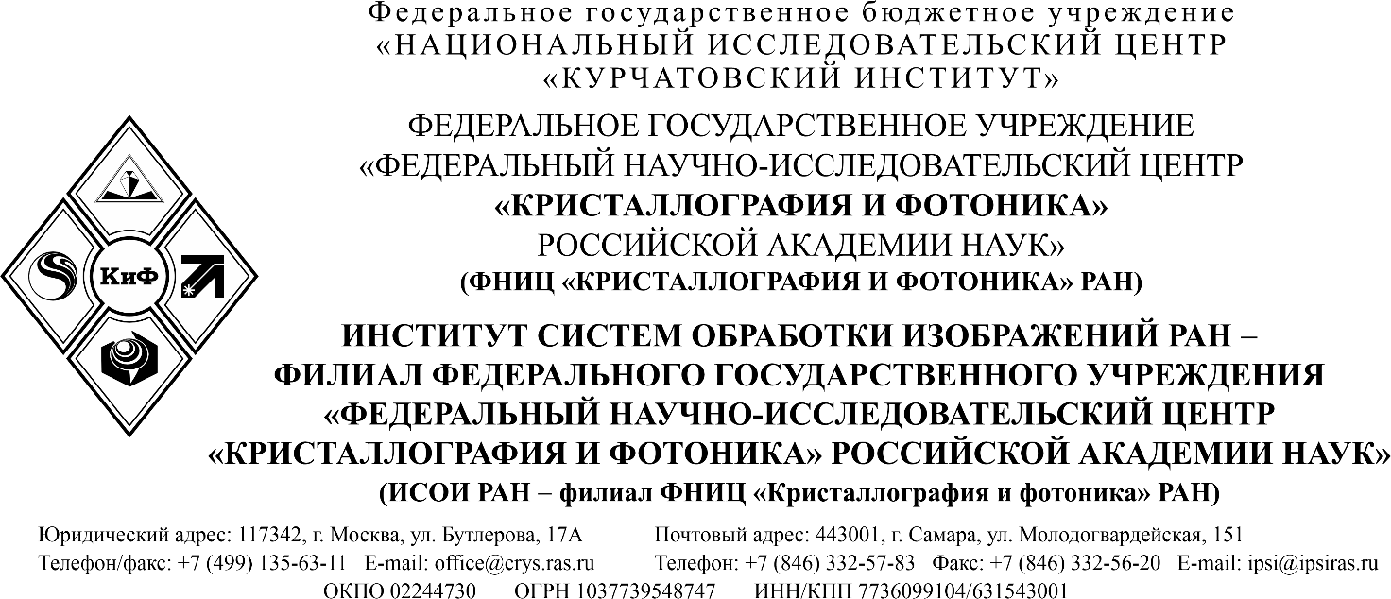
________________________________________________________________________________________________________________________________________________________________

______________№ 11205-
на №__________от_______________

