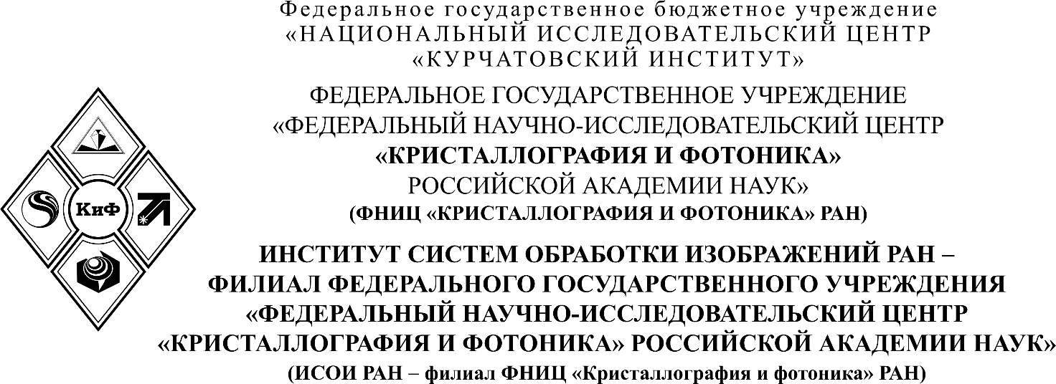
________________________________________________________________________________________________________________________________________________________________

П Р И К А З
______________ №_______________
Самара

